**Use case diagram for entire online library management system**

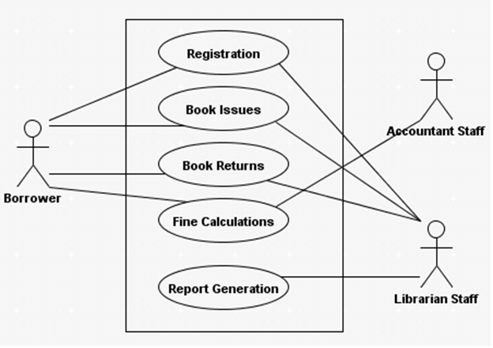

**Sequence diagram for Online Library Management System**

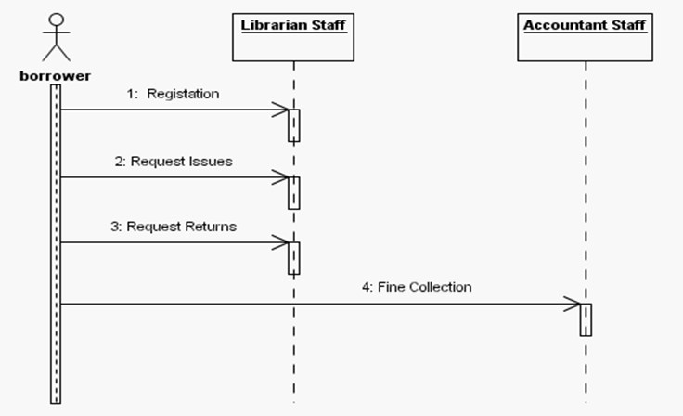

**Complete state diagram for Online Library Management System**

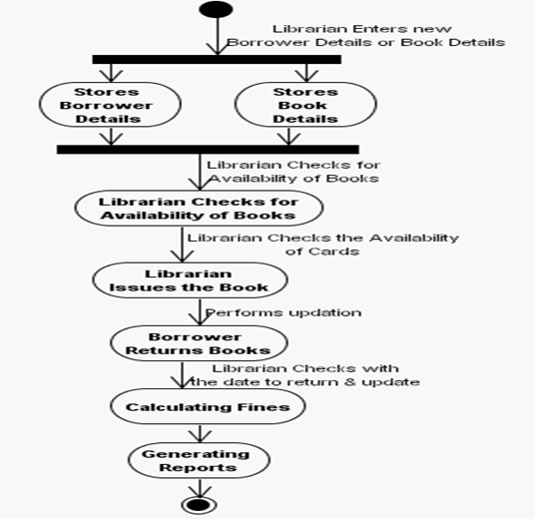

**Activity diagram for Online Library Management System**

